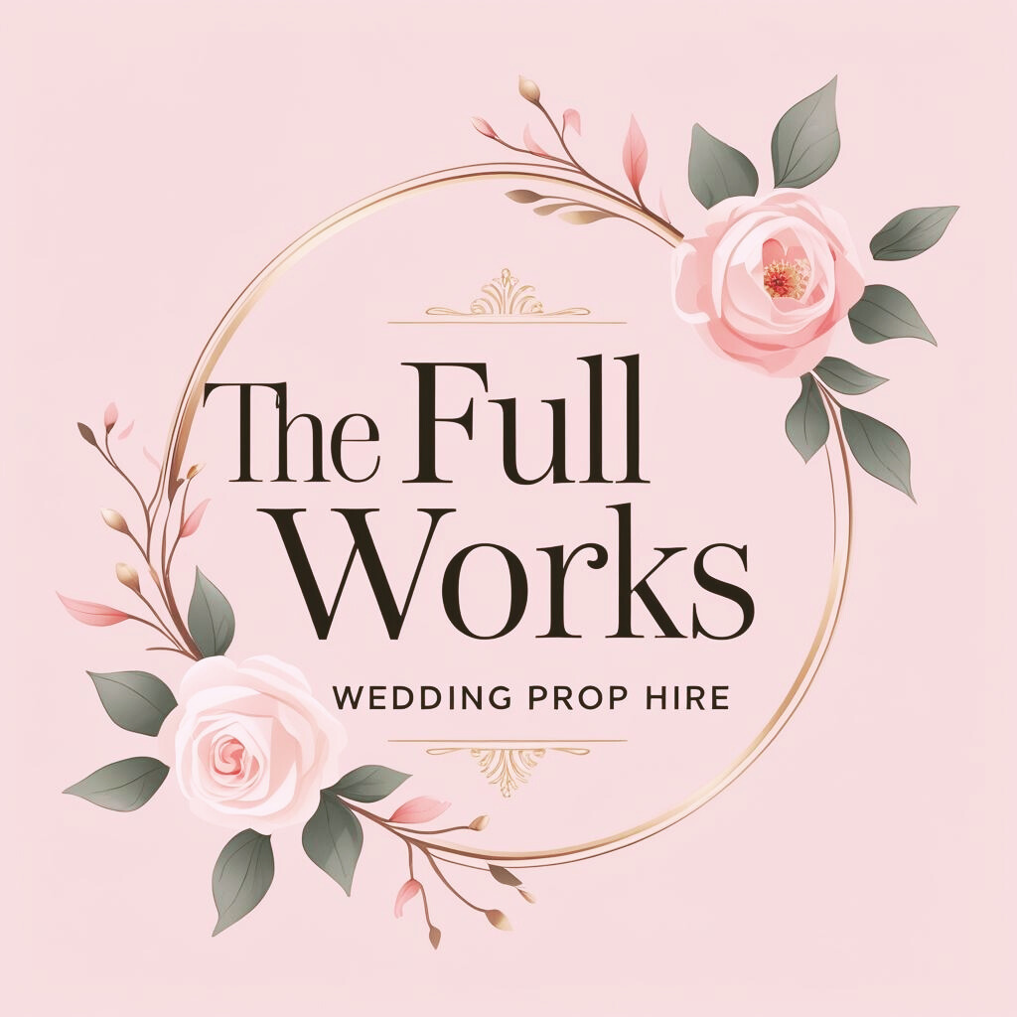

Our Signature Large Props
Any of our props can have faux foliage added on for a small fee

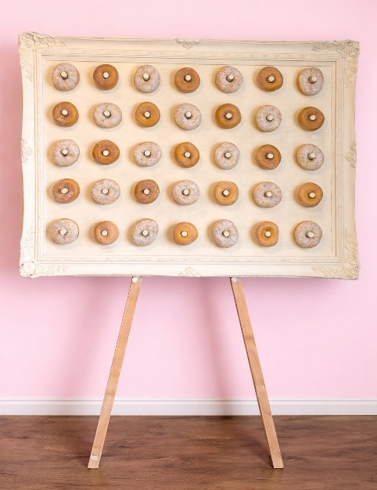
Shabby-Chic Donut Frame
Fits 35 donuts (to be supplied by you)
Comes with either a white or natural wood easel
£65

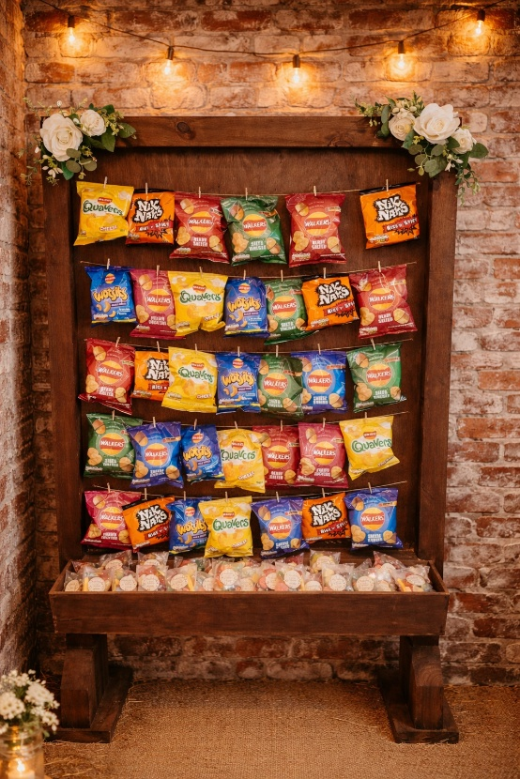
Large Wooden Crisp Wall
Comes with faux flower arrangements (can be removed)
Either plain mini wooden pegs, or white love heart pegs
Crisps/sweets to be supplied by you
£85

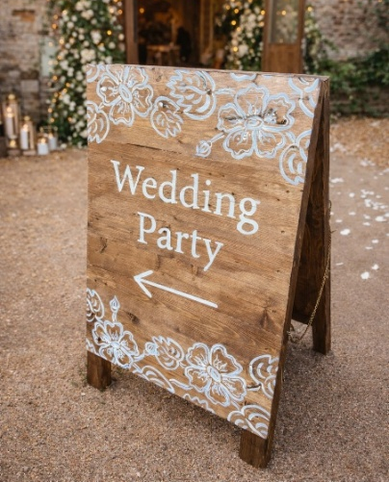
Wooden A-Frame Wedding Party Sign
Faux Foliage can be added on request
£60
Rustic Seating Plan Pallet
Comes with a white or wooden easel, faux foliage and a choice of plain mini wooden pegs or white heart mini pegs
£65
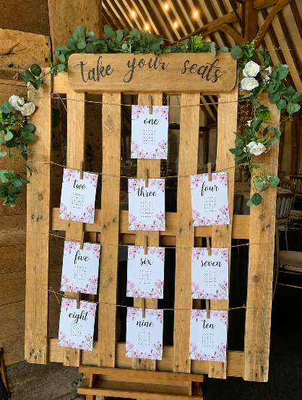
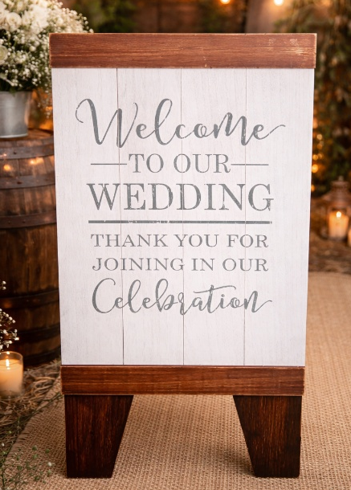
Wooden Welcome sign
Faux Foliage can be added on request
£35

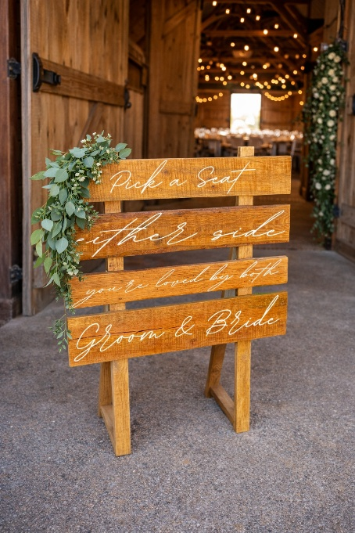
Pick a Seat Either Side, You’re Loved by Both Groom and Bride Sign
Faux Foliage can be added on request
£40
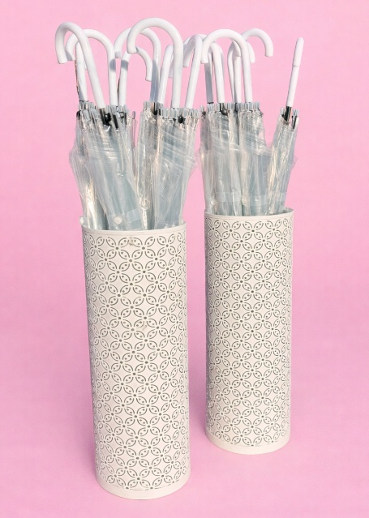
Clear Umbrellas with White Metal Stands
16 Umbrellas and 2 Stands
£40 for the set
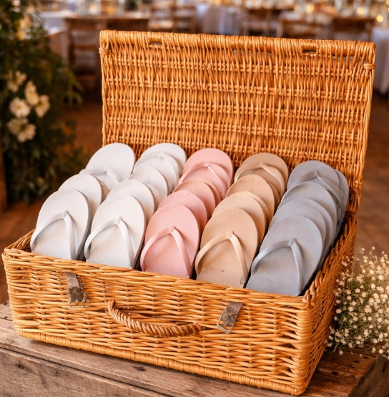
Larger Wicker Hamper
Great for flip flops, glasses, etc
£25
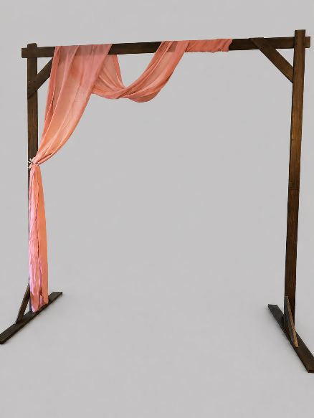
Rustic Wooden Arch
Add draping or faux flowers of your choice,
Great for framing cakes or entrance ways
2.28m
£125
Card Boxes
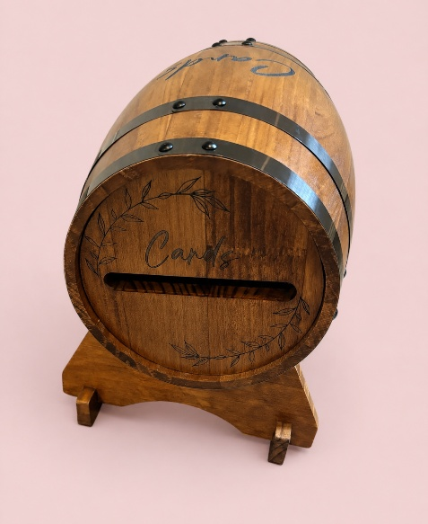
Wooden Barrel Card Box
Can be stood up or laid on stand
£30

Table Decorations & Centrepieces
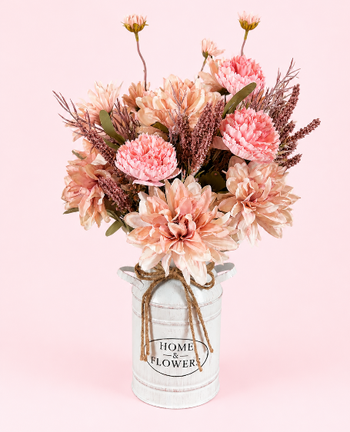
Pink Rustic Milk Churn Centrepiece
Beautiful pink faux floral arrangement in a white rustic small milk churn
£15 per item
10 available
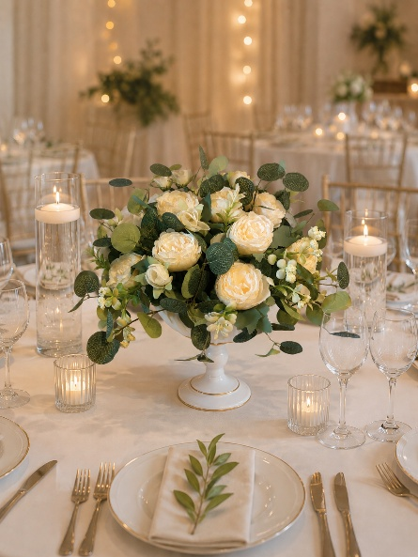
Faux Peony & Eucalyptus Vase
Elegant faux peony and eucalyptus arrangement in a white vase with gold detail
£20 per item
10 available
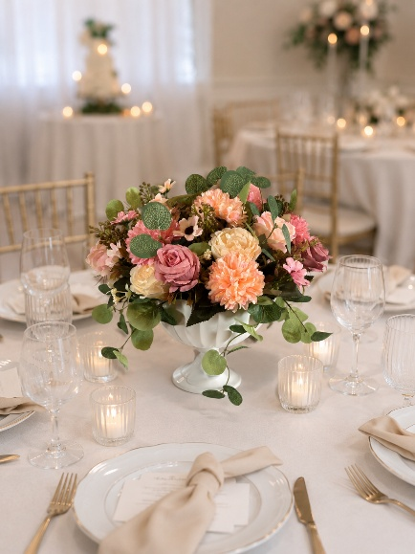
Faux Pretty in Pink Vase
Elegant faux flowers eucalyptus arrangement in a white vase with gold detail
£20 per item
10 available
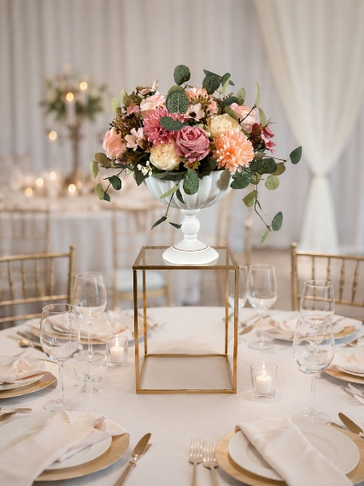
Gold Centrepiece Pedestal
Gold 40 cm tall pedestal, perfect for gaining some height with centrepieces (flowers not included, but can be hired separately)
£7.5 per item
10 available
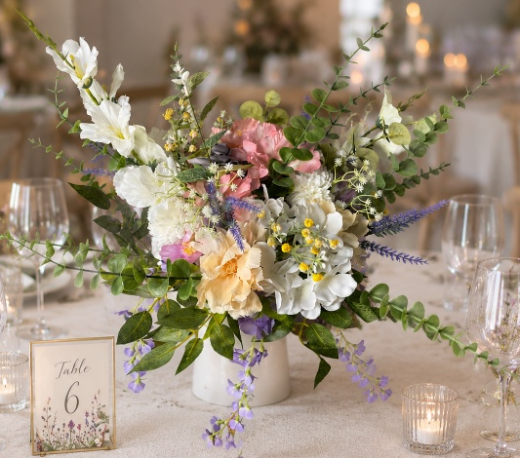
Wildflower Theme Faux Florals
Large wildflower themed faux floral arrangements perfect – check out our wildflower table numbers for a perfect match!
£30 per item
10 available

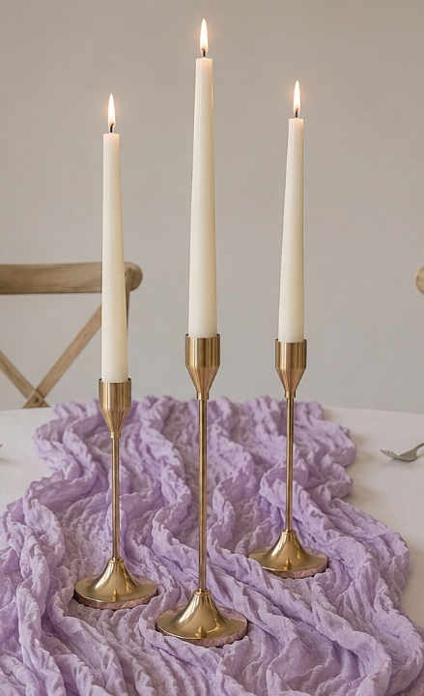
Gold Three-Tier Candle Stick Holders
We have 10 sets of 3 (30 in total) gold candle stick holders in three heights. We also have battery operated tapered candles available if your venue does not allow real candles to be lit.
£7.5 per set of three
10 sets available
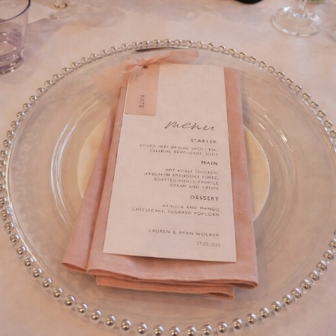
Silver Detail Acrylic Chargers
£1.50 per item
90 available
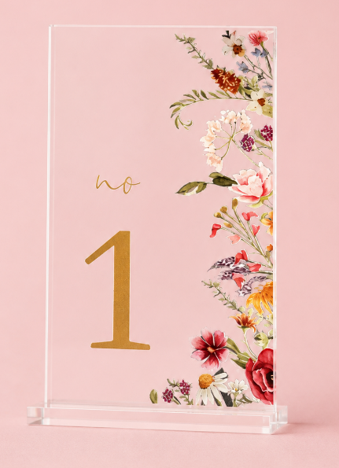
Wildflower Table Numbers
1-20
£1.00 per item
Match with our wildflower centrepiece!

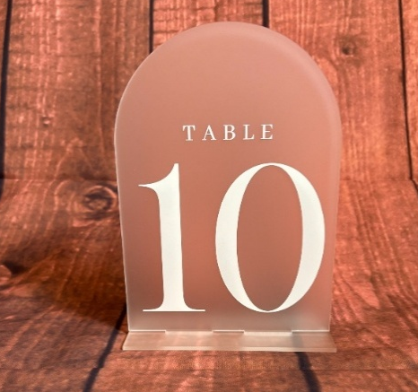
Frosted Acrylic Table Numbers
1-10
£1.50 per item

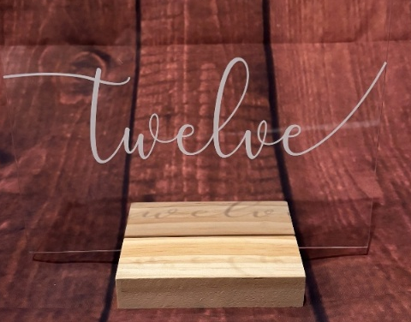
Clear Acrylic Table Numbers with Wooden Stands
1-12
£1.50 per item

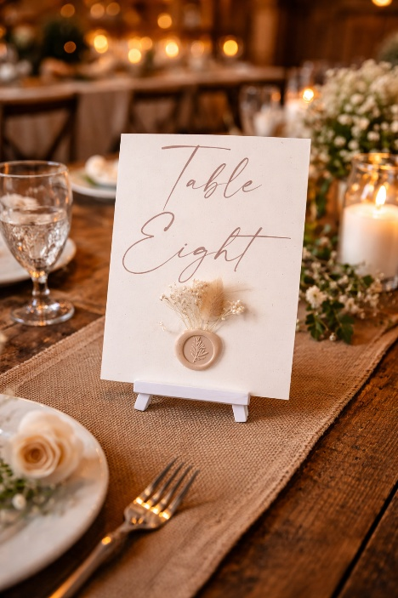
Rose Gold & Pink Wax Detail Table Numbers
1-8
£1.50 per item

Delicate Touches (It’s the little things that matter)
White Battery Lanterns
8 Lanterns (batteries included)
£3.50 per item

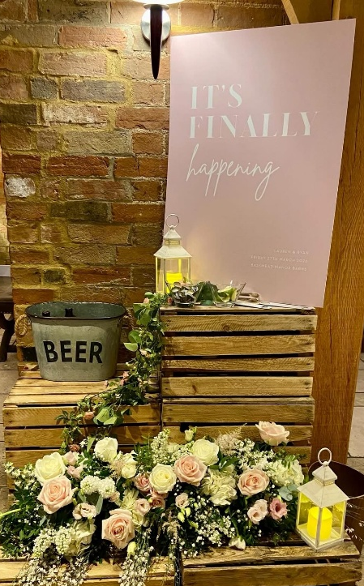
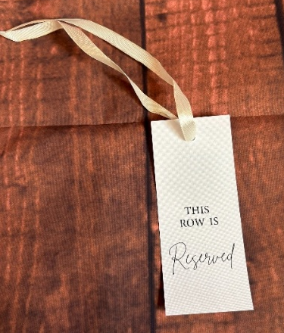
Row Reservation Tags – Cream Ribbon
12 tags
£1 per tag

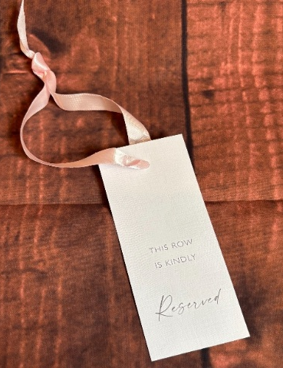
Row Reservation Tags – Pink Ribbon
8 tags
£1 per tag

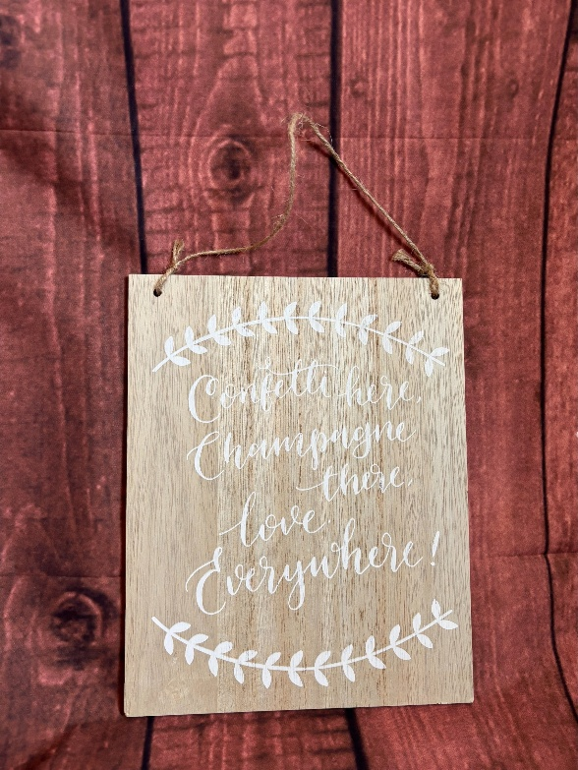

Wooden Hanging Sign 1
Confetti here, Champagne there, love everywhere
£4.00

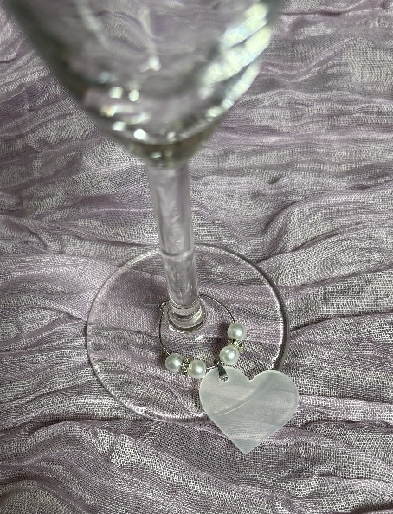
Love Heart Glass Charms
£7.50 for the set (72 charms)
Trust us – its these small details that people will talk about!

Acrylic ‘Please Sign Our Guestbook’ Sign
£3.50
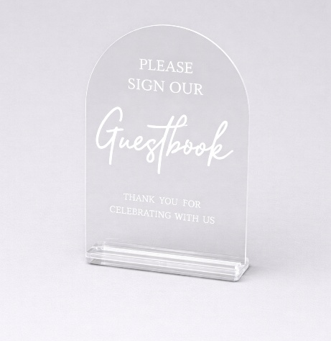

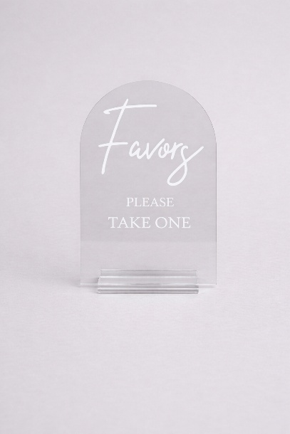
Acrylic Gifts and Cards Sign
£3.50
Acrylic Favours Sign
£3.50
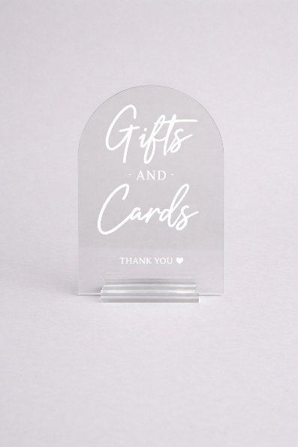
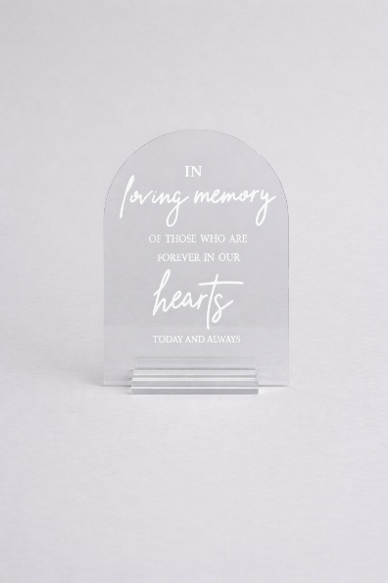
Acrylic In Loving Memory Sign
£3.50

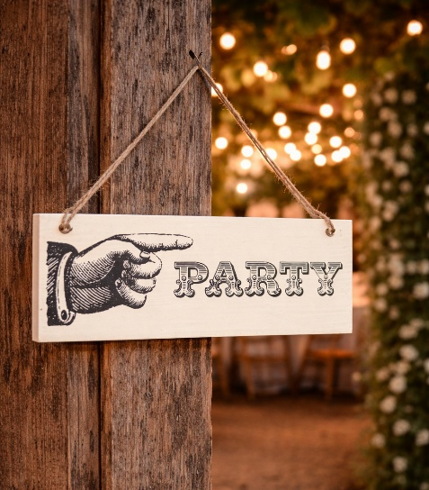
Small ‘To Have and To Hold’ Hanging Sign
£3.50
Small Party Hanging Sign
£3.50
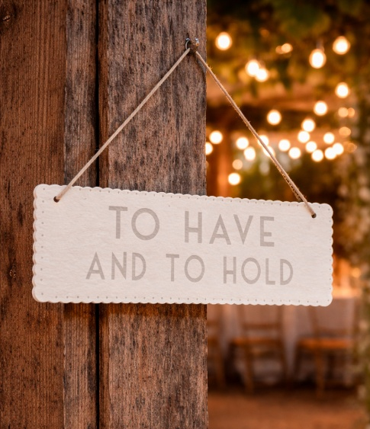
Small Welcome Hanging Arrow Sign
£3.50
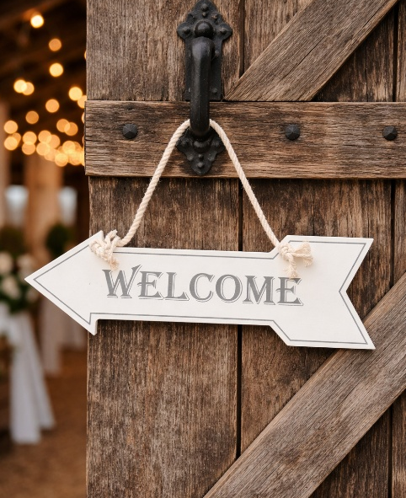

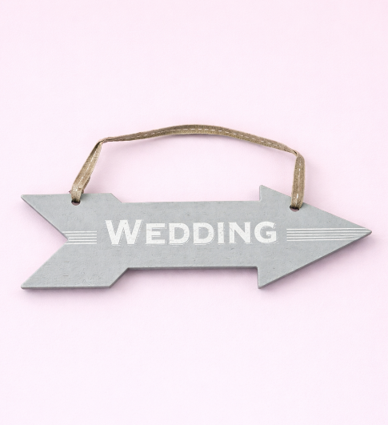
Small Wedding Hanging ‘This Way To The I Do’s’ Sign
£3.50
Small Wedding Hanging Arrow Sign
X2
£3.50
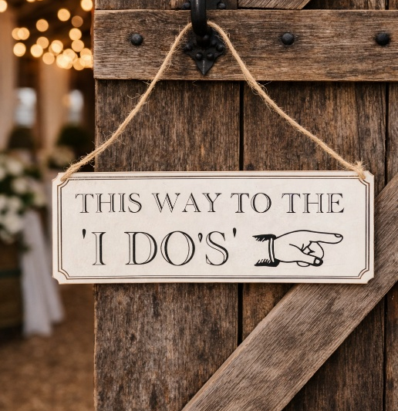
Wooden Hanging Sign 2
We decided on forever!
£4.00
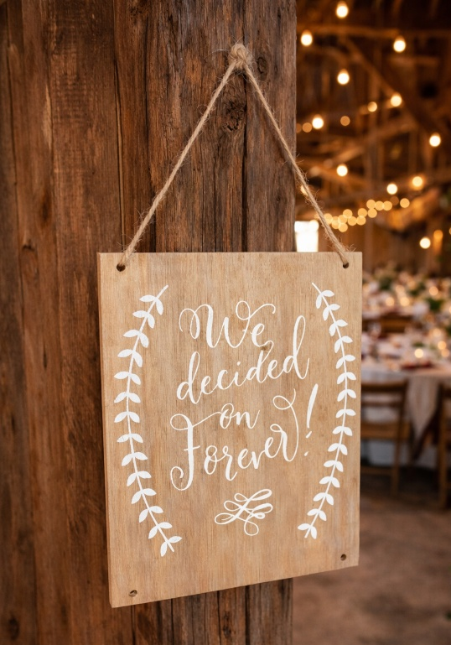

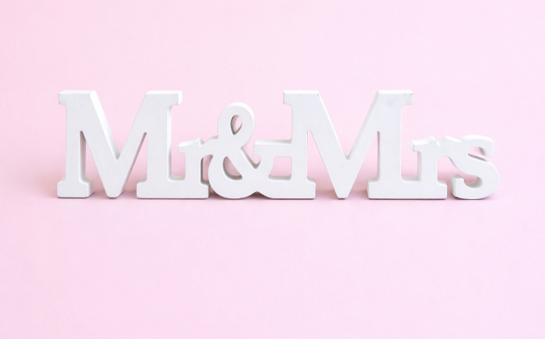
MR&MRS Sign 1
£3.50


MR&MRS Sign 2
£3.50

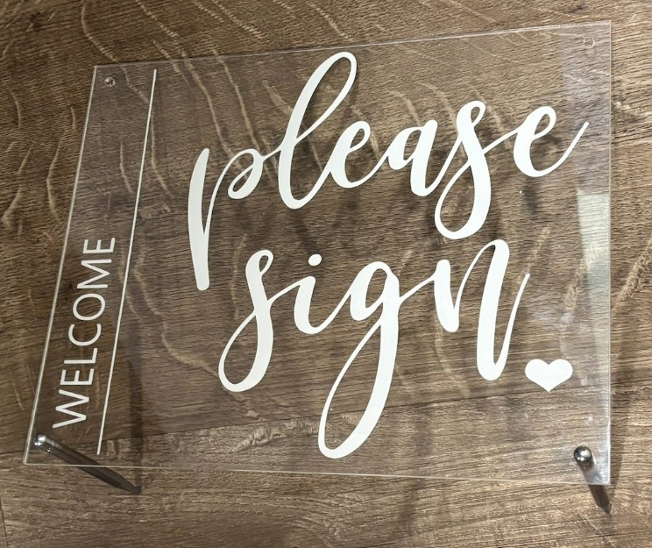
Please Sign Acrylic Standing Sign
£5
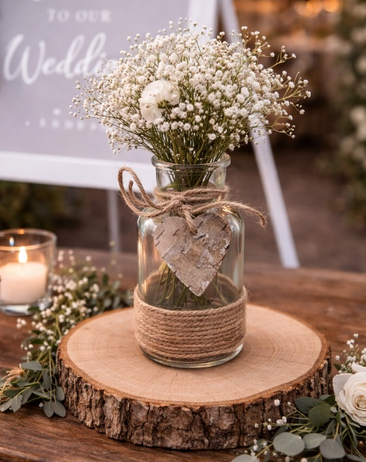
Glass Votive Jars
With twine and bark details
X12
£2.00 per item
White Wicker Basket
£4.00
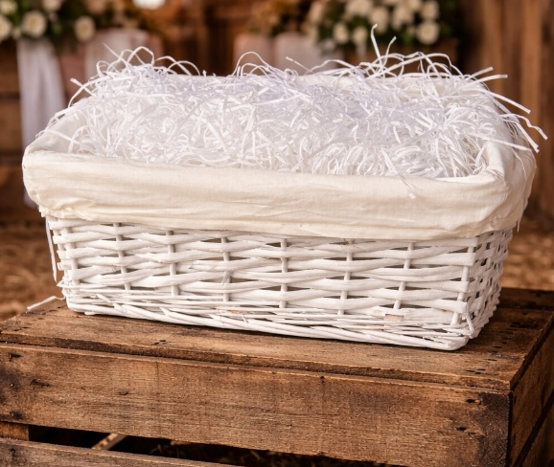
Brown Wicker Basket
£4.00
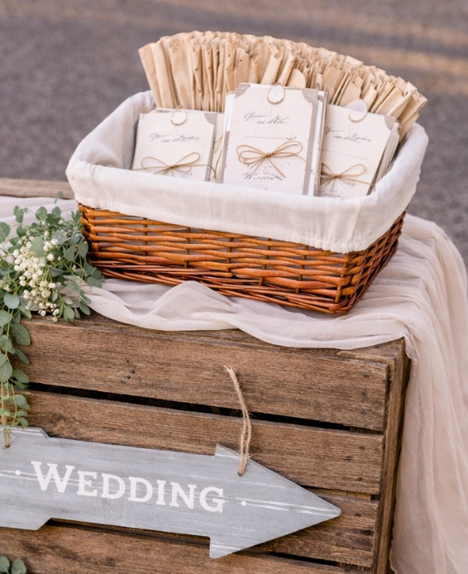
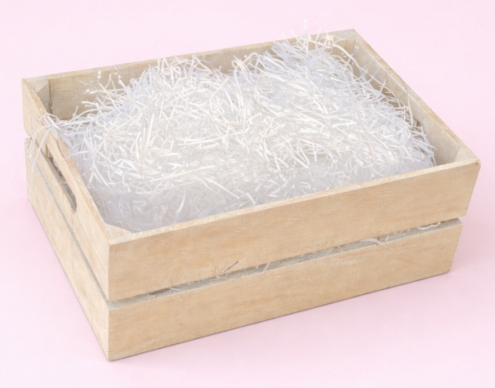
Grey Wooden Crate
X2
£5 per item

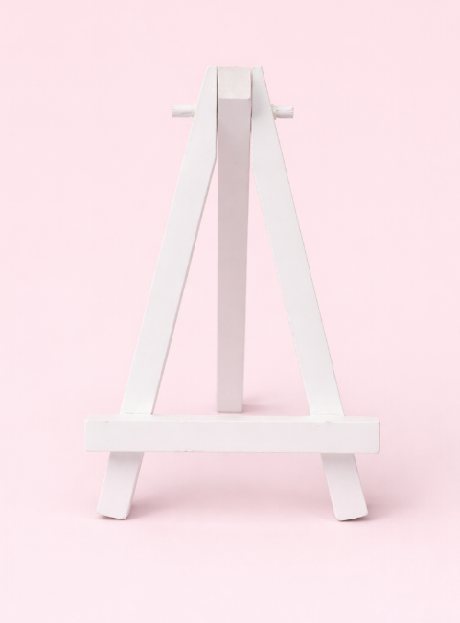
Mini White Wooden Easel
X11
£1 per item
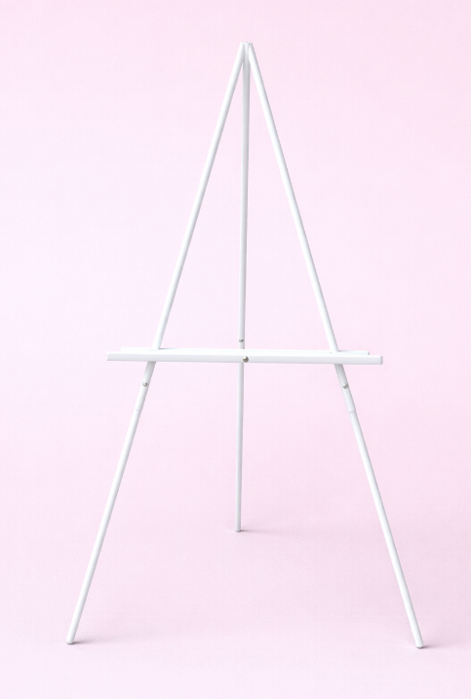
Large White Easel
X4
£10 per item
Faux Foliage
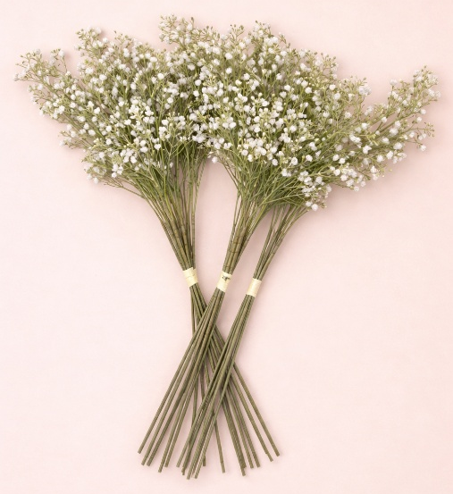
Large Long Stem Gypsophila Bunches
X2 large bunches, can be split
£5 per bunch
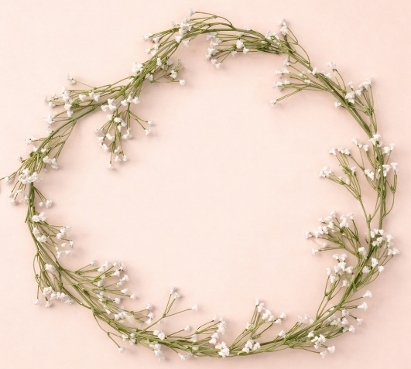
White Gypsophila Garland
1,8m long x2
£4 per garland
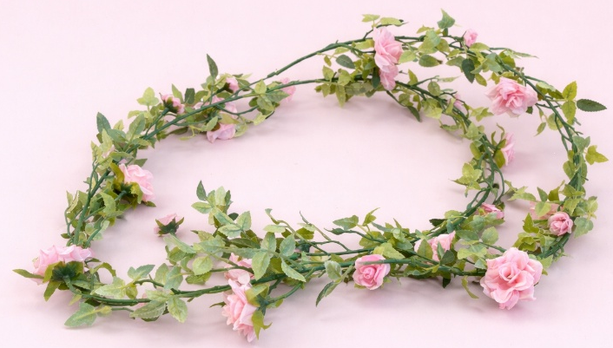
Pink Flower Garland
1,5m long x3
£3 per garland
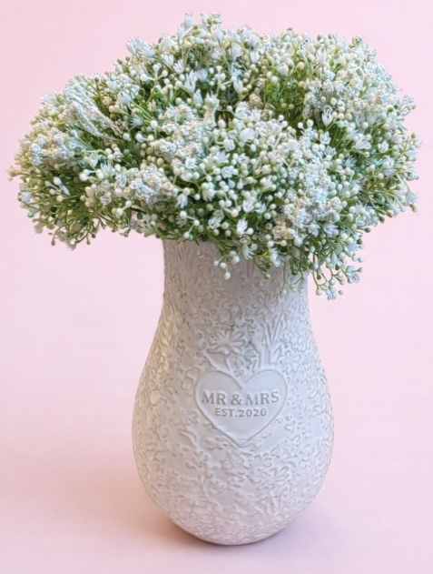
Eucalyptus Garlands
1.8m x3
£5 per garland
Smaller Gypsophila Bunches
X4 bunches
£3 per bunch
Vase not included
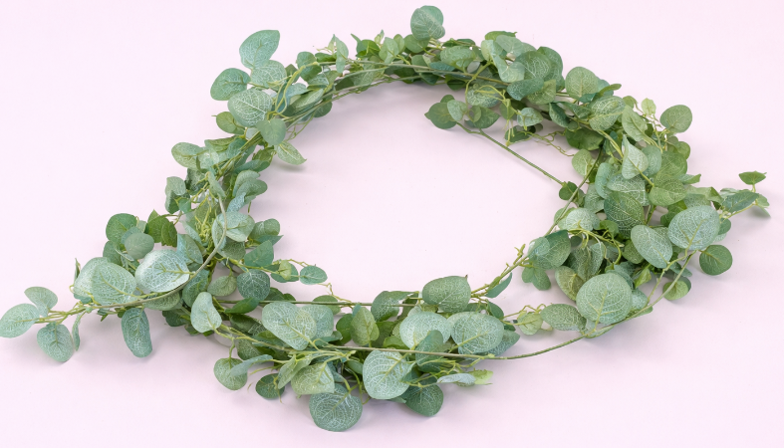
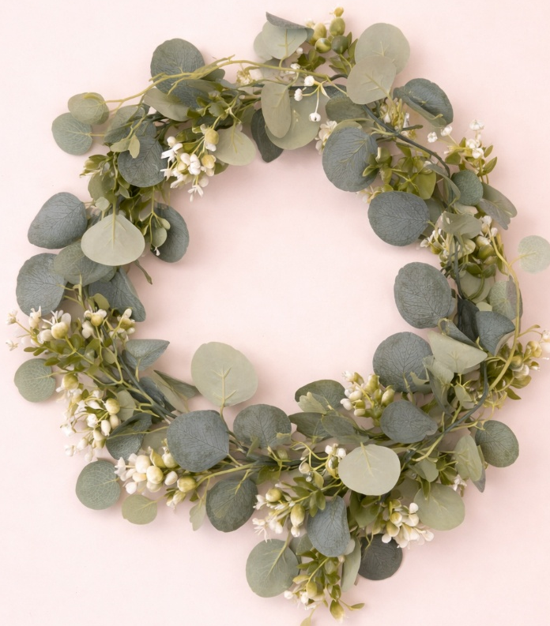
Eucalyptus & White Flower Garlands
1.8m x3
£5 per garland
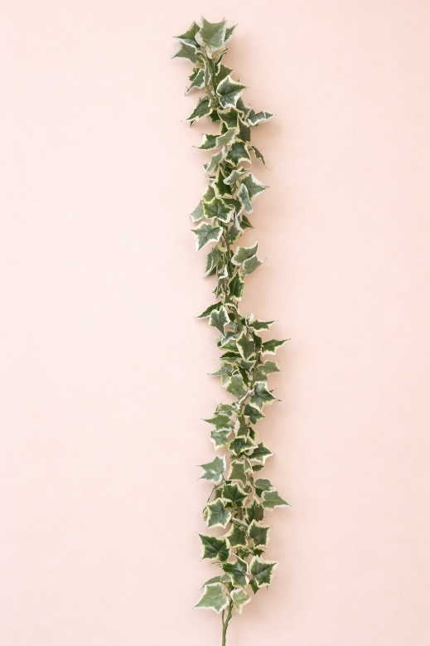
Ivy Garlands
1m x3
£4 per garland

Chair Sashes & Table Runners
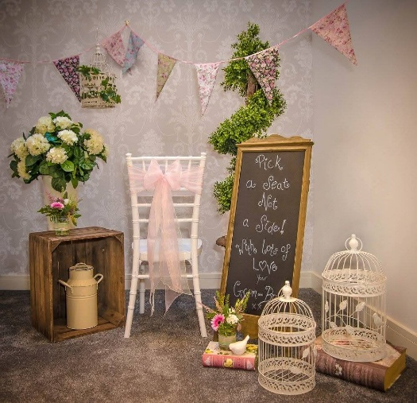
Baby Pink Chair Sashes
X166
£2 per sash
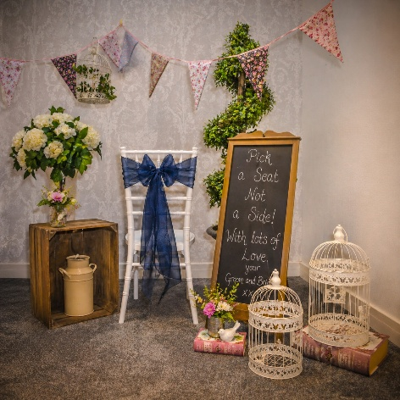
Lemon Chair Sashes
X115
£2 per sash
Navy Chair Sashes
X60
£2 per sash
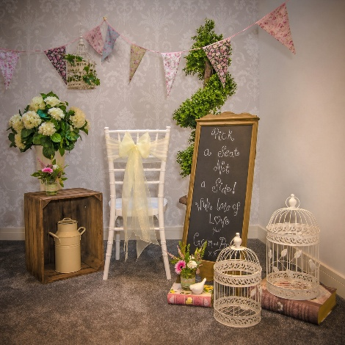
Gun Metal Grey Chair Sashes
X83
£2 per sash
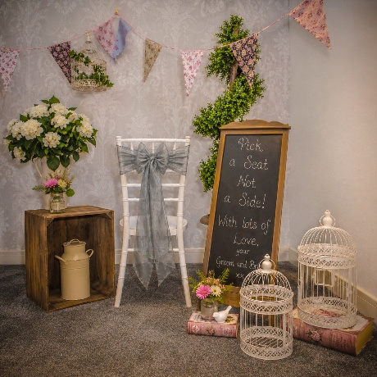
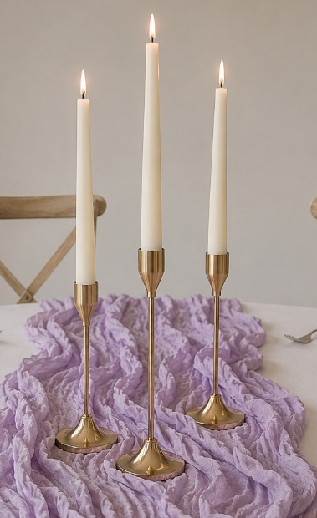
Sage Cheesecloth Table Runners
15 available
£2 per runner
Lilac Cheesecloth Table Runners
30 available
£2 per runner
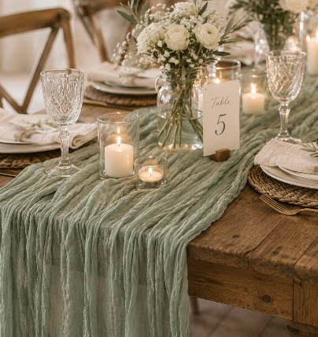

Ts&Cs
Orders over £500 receive free delivery & collection. Orders under £500 will be subject to a £50 delivery & collection fee
A payment of 25% of your total will be required upon booking to secure your date and items. 50% of the remaining balance will fall due 6 months before the date of your wedding. The final 50% will then fall due 1 month before your wedding date.
Any of our items can have faux foliage added for an extra fee – please ask for more details.
Minimum spend of £250 applies.

